Week 3 Report

Neural Networks

In this week we discussed the basics of neural networks and their working using pytorch.

We discussed about:

* Tensors which are the core data abstraction of pytorch.
* Autograd that drives the eager mode computation that makes rapid iteration in the model.
* Building a model using pytorch models
* Efficient loading of data and training models
* Deployment with torch script

Creating a matrix 5x3 with all zero and find its datatype (float):

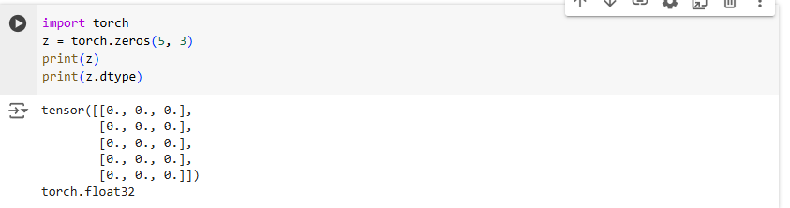

Using integers instead:

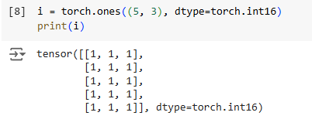

Random tensors generated with the same seed are the same:

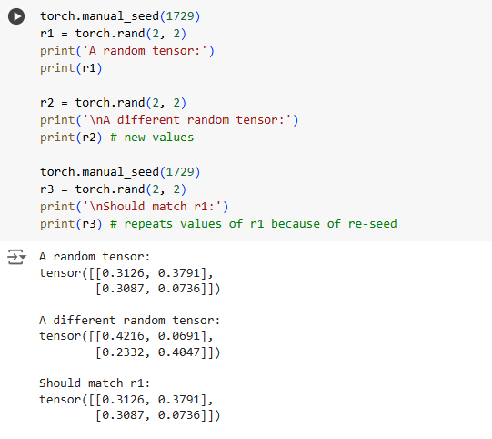

Arithmetic operations can be performed on tensors with the same size:

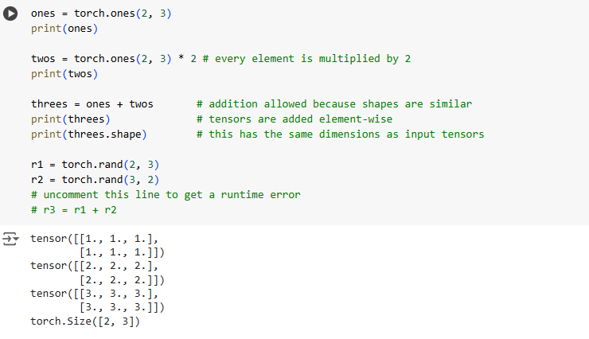

Example of a neural network

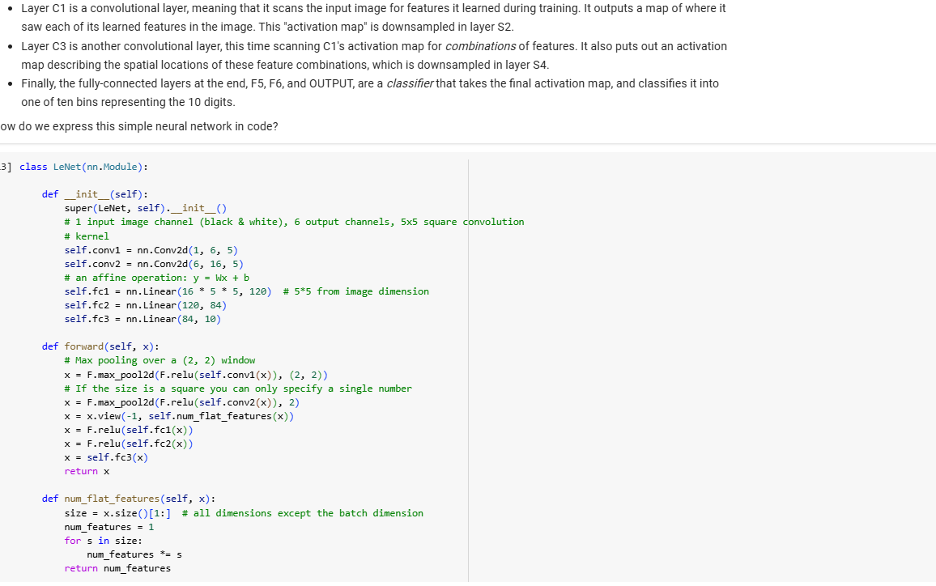

The output of this call represents the model's confidence that the input represents a particular digit.

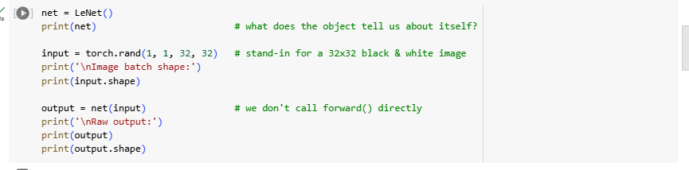

 Transforming our incoming images into a PyTorch tensor:

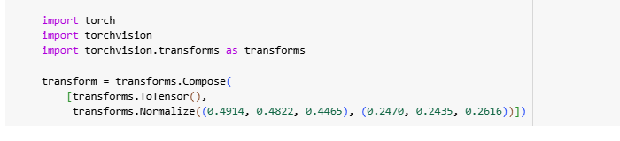

 Creating an instance of the CIFAR10 dataset and generating and shuffling 4 images:

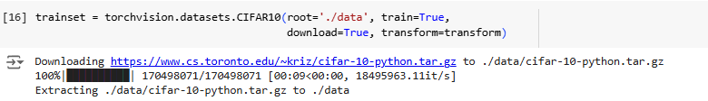

Running the above cell should show you a strip of four images, and the correct label for each.

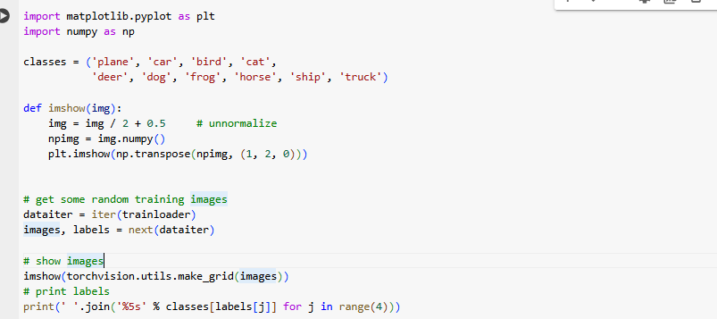

Training your model:

Downloading training and test datasets.

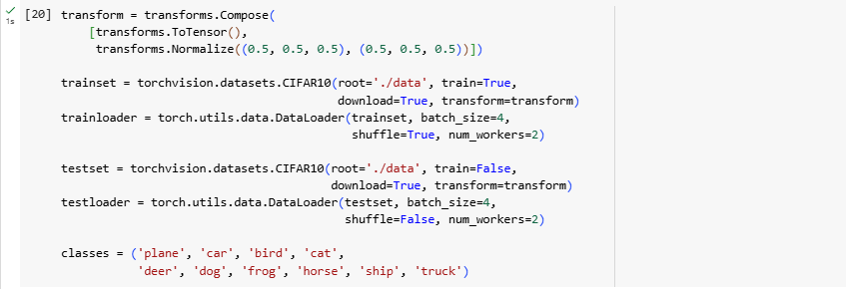

Checking output from the data loader:

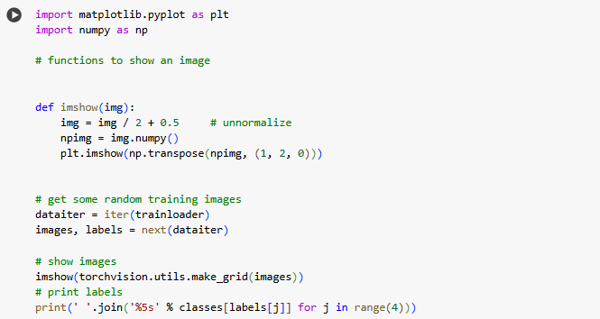

Model to train:

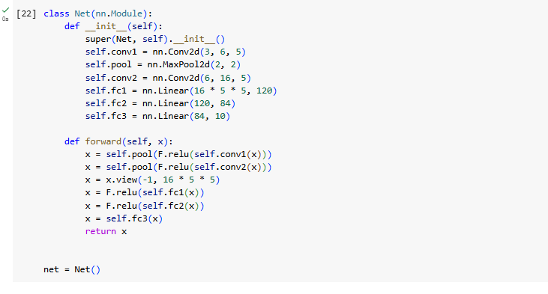

Loss function and optimizer:



Assembling these in the training loop:

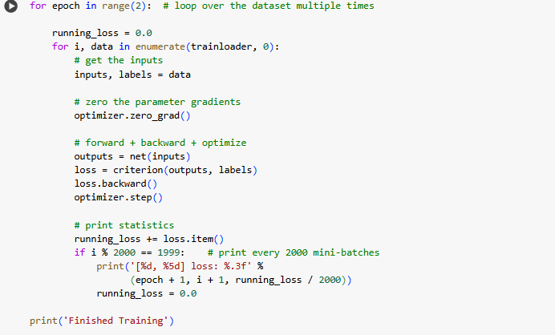

As a final step, we should check that the model is actually doing general learning, and not simply "memorizing" the dataset.

